Sources of further guidance regarding online safety

Digital Parenting Magazine
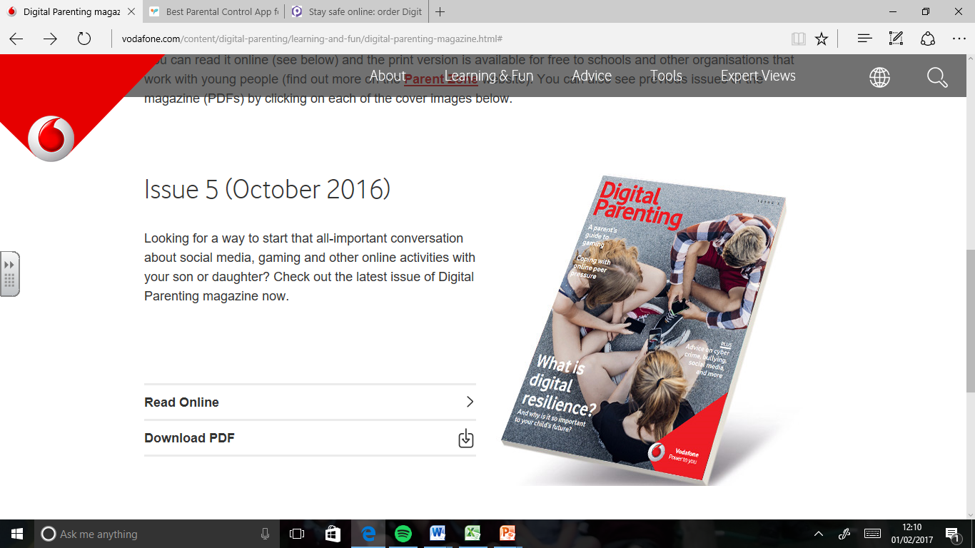
Online magazine produced approximately annually by Vodafone using layman language. Links to current edition including articles about setting family technology rules.
Historic editions can be viewed here.

Ourpact.com
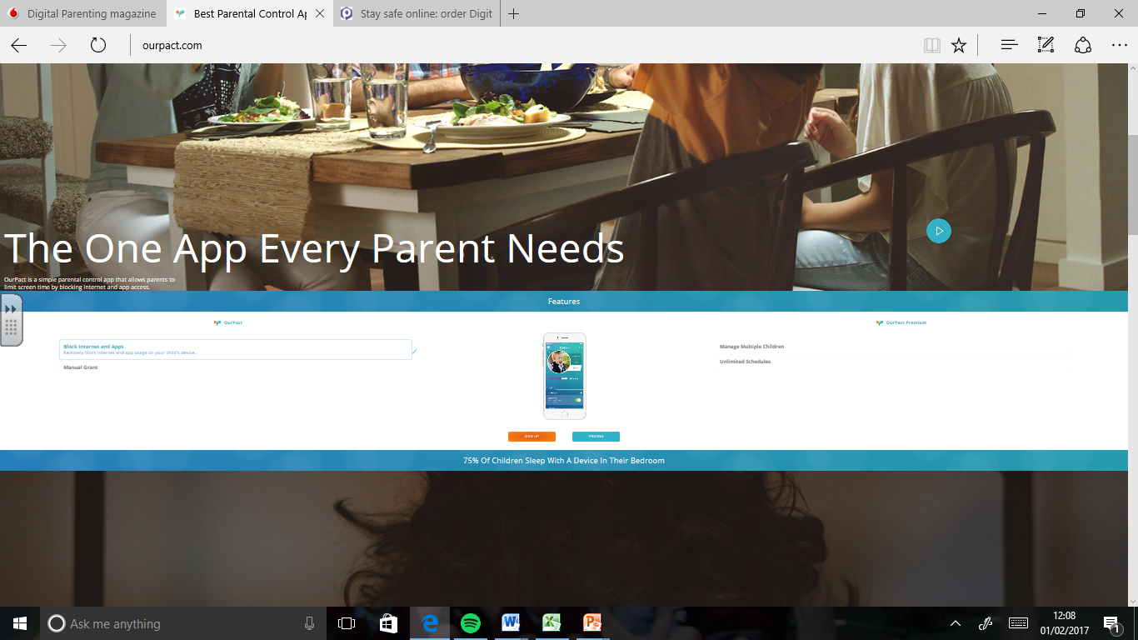
App to give controls over all household devices (iOS & android). The ‘pact’ is reached collaboratively as a family and seeks to teach proper device habits. A well-regarded resource by experts. Can block access to internet/ apps as well as limit screen time.

CEOP
The Child Exploitation Online Protection website is managed by the National Crime Agency. The Parent zone breaks down the jargon and there is a facility to report an issue which they are duty bound to respond to.
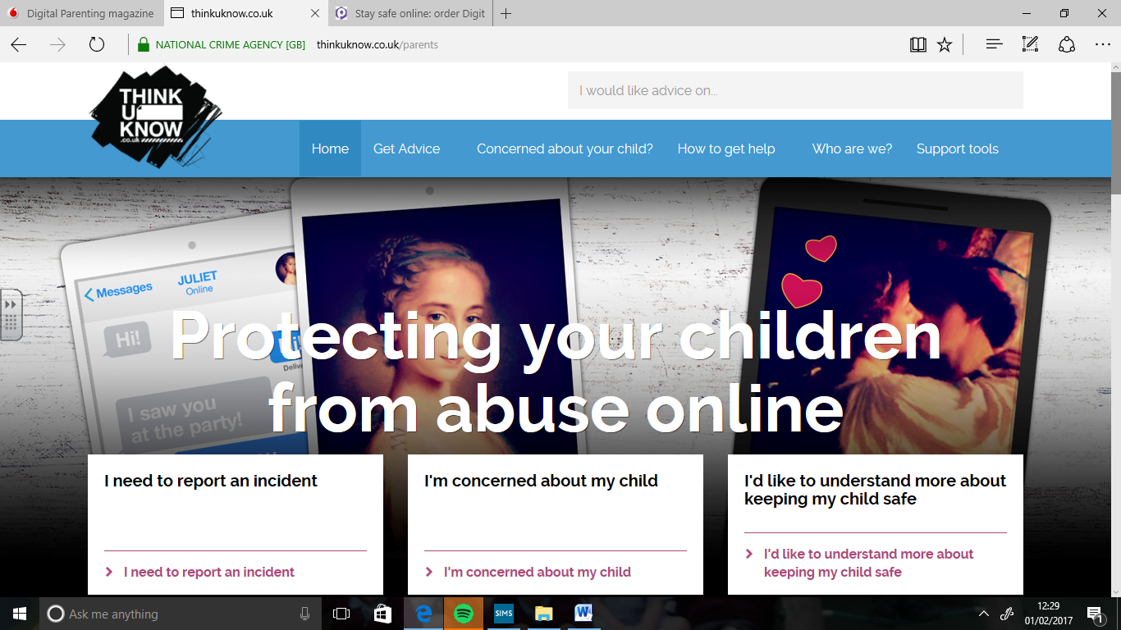

Internetmatters.org
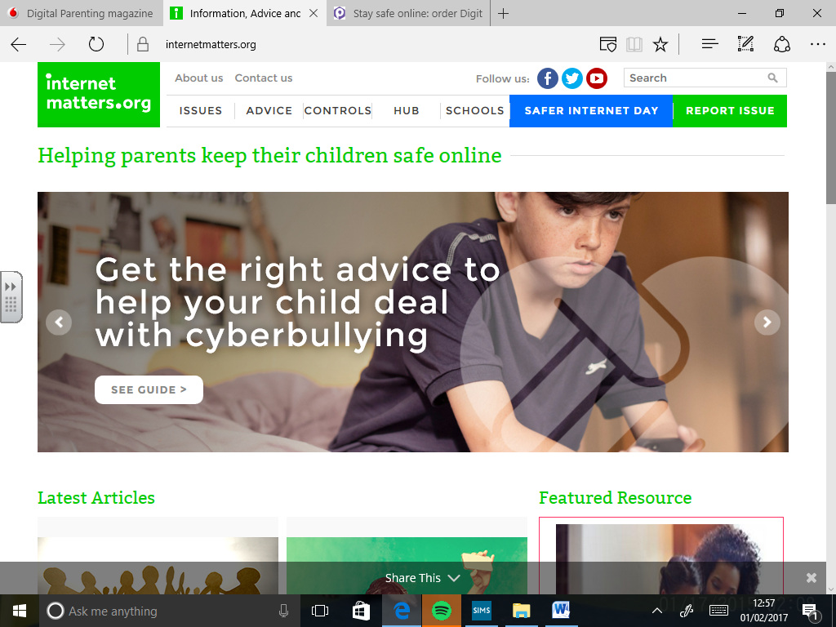
Enables parents to build a digitally safe home – guiding you through step by step to set up parental controls.

Parentzone
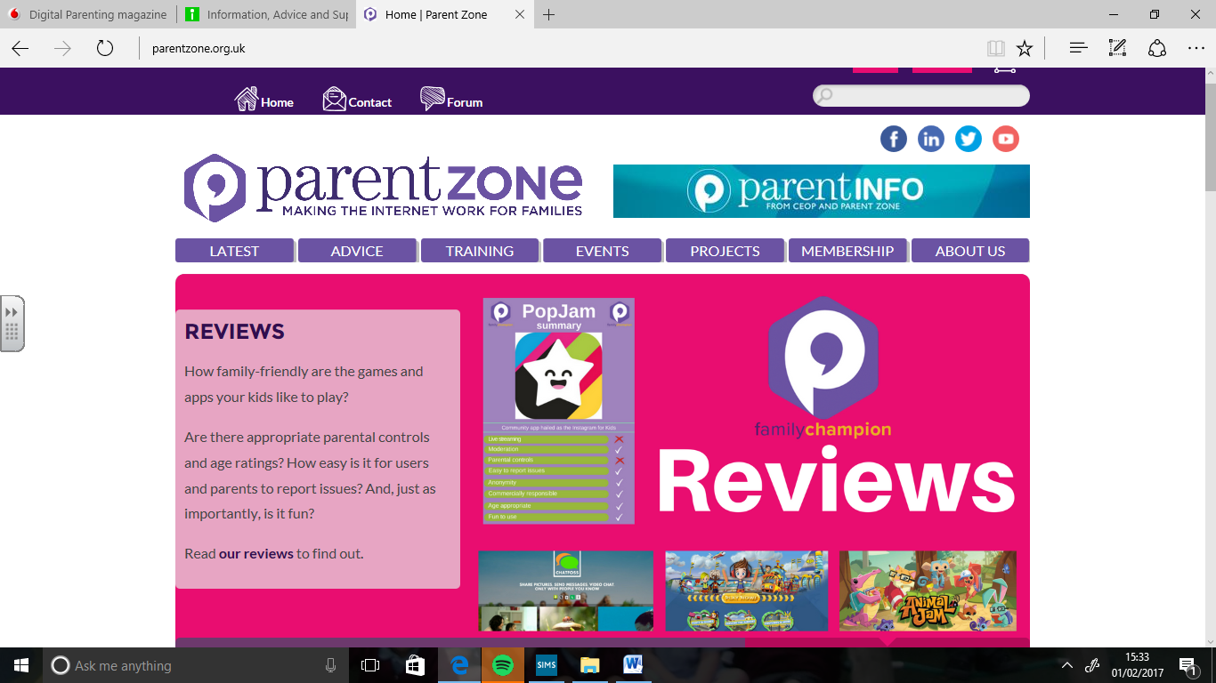
A really useful site which examines which new games & apps are family friendly.

