Our school values of love, respect and unity, together with our Christian distinctiveness, underpin our ethos. We have a PSHE curriculum that helps students to build important life skills, such as a growth mind-set. |  |  |  |  |  |  | 
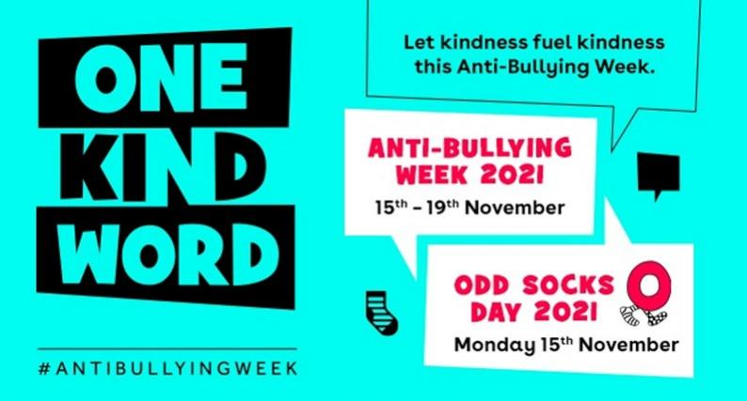 |  |  |  | We mark significant events like ‘Random Acts of Kindness Day’ and ‘Children in Need’, Black History month and ‘Anti-Bullying week’. |  |  |  |  | 
We practise positive behaviour management strategies including restorative justice. |  |  |  |  |  | 
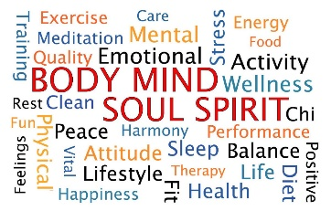 |  |  | All children have weekly PE lessons taught by our dedicated sports coach as well as access to a range of extra-curricular clubs, for example,’ bounce & catch’, football and netball to encourage our children to be physically active. A healthy body and healthy mind are intrinsically linked.
We hold ‘Nurture and Natter’ sessions twice weekly after school for children in Y1-6 with a focus on fostering emotional well-being through activities such as gardening and fundraising for charity. |  |  |  |  | We offer extended parent consultations with both the class teacher and SENDCo present to facilitate discussions around well-being if there is a concern.
The children can share their worry with a trusted adult by writing about it and posting it in a class ‘worry box’. This alerts a member of staff and prompts a discrete check-in or discussion. |  |  |  |  |  |  |  |  | 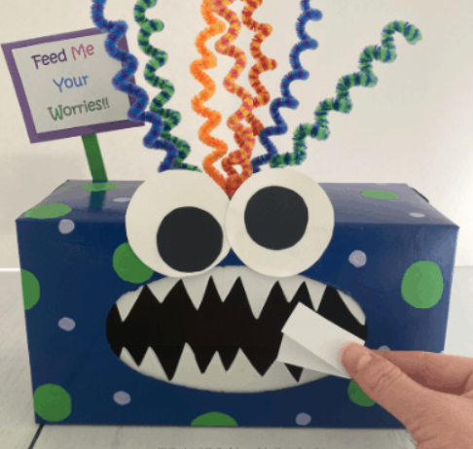
 |  | We host a daily ‘lunch club’ to support children who are finding elements of lunchtime difficult to manage, for example, their friendships.
Y5 buddies support younger children in developing positive play on the infant playground each lunchtime. |  |  |  |  |  |  |  |  | 
 | Mrs Watts, our Home-School Link Worker, supports children in small groups or individually, for example, to develop self-esteem.
Children have the opportunity to indicate what they are feeling ‘in the moment’ to a trusted adult through accessing their class feelings display. |  |  |  |  |  |  |  | 

