Website (hyperlink via image) | Overview
 | Offer a range of resources to help parents support children who are feeling anxious. Particularly useful elements (follow hyperlinks within each bullet):  - Parent survival guide  - Advice on a range of issues from gaming to social media
 | Dedicated to suggesting picture books to supporting children through different topics, for example, a new baby or a fear of the dark.
 | Top 10 mental wellbeing and mindfulness apps for all the family; created by Parentzone, experts in family digital life.
 | The advice line is available from 8am to 5pm, Monday to Friday and provides support on all aspects of child health, development and parenting.
 | Advice for parents and carers to help them support a child or young person experiencing poor mental health or well-being. They have a particularly useful document about how to support your child if they are worried which can be accessed here.
 | Mindfulness equips children with tools to build self-esteem, manage stress, and skilfully approach challenges.
 | Getting children outdoors and exploring green spaces can ease anxiety, reduce stress, and improve their mental wellbeing.
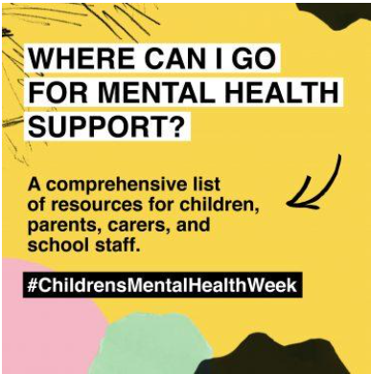 | Useful links and sources of mental health support collated by The Education Hub so that children and young people and parents get the advice and help they need
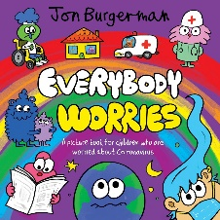 | ‘Everybody Worries’ is a free picture book by Jon Burgerman to help children appreciate it is ok to be worried, for example, about the pandemic.
 | This publication brings a refreshing twist on what we typically know as 'news' reporting on positive changes and truly inspiring people. Sign up for a free, regular newsletter.
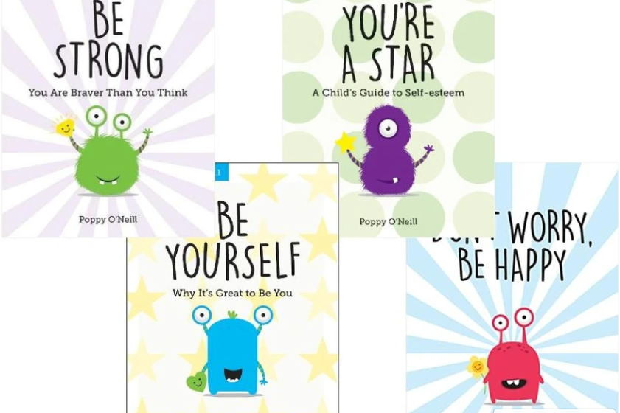 | Poppy O’Neill has written a series of books aimed at children aged 7-11. This practical guide combines cognitive behavioural therapy and mindfulness methods with simple activities to help your child. Your child will be guided through fun and engaging activities which are interspersed with useful tips, inspirational statements and practical information for parents.

